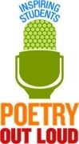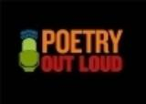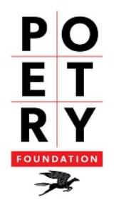

Metro Tech High School Competition: February 1, 2019
- Winner will compete in the regional competition for a chance to compete at the state level
- Will be honored as Metro Tech’s 2019 Poetry Out Loud winner

Arizona Regional/State Competition: February 16, 2019
- Each winner at the state level will receive $200 and an all-expenses-paid trip to Washington, D.C. to compete the in the National Finals
- The state winner’s school will receive $500 for poetry materials
- One runner-up in each state will receive $100; the school will receive $200

National Competition, Washington, D.C.: April 30-May1
- A total of $50,000 in awards and school stipends
- $20,000 for the National Champion

How do I sign up? Use this QR code or see Dr. Pelotte in Room 8221.
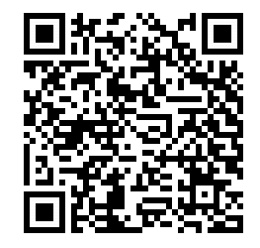
Congrats! You have found one of our secret poems!

Now what? You are part of our first poetry chain. What to do:

- Bring this poem to Room 8221 before school, after school, or during lunch/advisory.

- Recite the poem. (No, you do not need to memorize it!)

- Collect your prize and learn about Poetry Out Loud.

- Pass your poem along to a friend to keep the poem chain going.

Congrats! You have found one of our secret poems!

Now what? You are part of our first poetry chain. What to do:

- Bring this poem to Room 8221 before school, after school, or during lunch/advisory.

- Recite the poem. (No, you do not need to memorize it!)

- Collect your prize and learn about Poetry Out Loud.

- Pass your poem along to a friend to keep the poem chain going.

