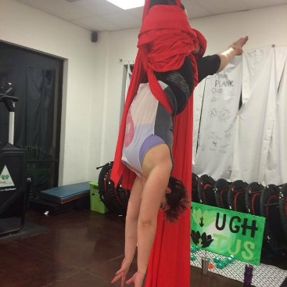
Bruises of Honor
“Go! Don’t give up! Fight for it!” I heard my trainer, Marnie, yell as I tried fruitlessly to coax my tired body into the right position in the air. The nylon of the fabric tightened painfully around my hips, cutting into my thighs. In that moment, I felt my circulation slowing to a crawl in my lower extremities. Okay, so maybe I will never be in Cirque du Soleil, but nothing can compare with the feeling of hanging mid-air supported only by one’s own strength and a set of nylon silks. I was attempting my first drop, in which I was supposed to dive forward in a somersault and trust that the fabric would hold me and prevent my head from colliding suddenly with the ground below, padded only with a standard gym mat that would have been about as useful as a dry kitchen sponge were my head to actually hit the ground.
The silks were secured around my ankles in what is known as a foot-lock. This prevents the aerial artist from plummeting as much as thirty feet to the ground below. The fabric was also looped around my hips in what is called a diaper-wrap—a misfortunate, yet accurate description of what the move looks like. My heart raced as my tired fingers gripped the silks. I knew I had to let go if I was going to complete the drop, but my hands would not cooperate. They remained stuck to the fabric as if glued with an invisible force.
“I can’t.” I said finally, defeated by the fabric and my lack of blood-flow and courage. Slowly, I untangled myself, descending from the silks as was taught, gracefully, with arms floating through the air—one then the other—until I landed safely on the ground. I looked at Marnie. She looked back at me with thinly-veiled frustration. I recognized that look of disappointment. She knew that I was the only thing standing in my own way.
“You’ll get there,” she said, attempting to assuage my obvious disappointment in myself.
“Failure is good, right?” I smiled. “It means I’m one less failure away from success.”
Bolstered by my failure, I re-ascended the silks, determined to be fearless, or at least less fearful. I wrapped my ankles, one by one, crossed the fabric behind and pulled by shoulders through. I lifted my hips up and over until I was flying, very much resembling a caped superhero. This time, with my hips securely wrapped in the fabric, a leaned forward, letting go of my hands. Whoosh! The drop was sudden, the pain behind my knees was sharp as I was caught by the fabric. “There are bound to be bruises,” I thought. But they will be bruises I have earned, bruises of honor, I decided.
“Whoo, hoo!” Marnie cheered.
I beamed, eager to try the drop again.
Since that time, I have suffered many more bumps and bruises during my training. More than anything else, my circus adventure has taught me to value failure as much as I value success. Failure is not something to be avoided. Failure is a friend, a mentor, a teacher who gives the very best feedback. Failing at one’s passion is not failure at all—it is part of the process that leads to self-discovery. The failures continue to arise, and I embrace the secret that each successive failure has to tell me. I relish each bump, each bruise, for I have earned each one.

