Home › Perspectives › Humanism › Maslow

Maslow's Hierarchy of Needs
by Saul McLeod published 2007, updated 2014

Maslow wanted to understand what motivates people. He believed that people possess a set of motivation systems unrelated to rewards or unconscious desires.
Maslow (1943) stated that people are motivated to achieve certain needs. When one need is fulfilled a person seeks to fulfill the next one, and so on.
The earliest and most widespread version of Maslow's (1943, 1954) hierarchy of needs includes five motivational needs, often depicted as hierarchical levels within a pyramid.
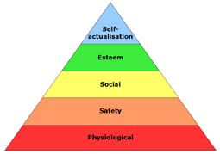
This five stage model can be divided into basic (or deficiency) needs (e.g. physiological, safety, love, and esteem) and growth needs (self-actualization).
The deficiency, or basic needs are said to motivate people when they are unmet. Also, the need to fulfil such needs will become stronger the longer the duration they are denied. For example, the longer a person goes without food the more hungry they will become.
One must satisfy lower level basic needs before progressing on to meet higher level growth needs. Once these needs have been reasonably satisfied, one may be able to reach the highest level called self-actualization.
Every person is capable and has the desire to move up the hierarchy toward a level of self-actualization. Unfortunately, progress is often disrupted by failure to meet lower level needs. Life experiences, including divorce and loss of job may cause an individual to fluctuate between levels of the hierarchy.
Maslow noted only one in a hundred people become fully self-actualized because our society rewards motivation primarily based on esteem, love and other social needs.

The original hierarchy of needs five-stage model includes:
1. Biological and Physiological needs - air, food, drink, shelter, warmth, sex, sleep.
2. Safety needs - protection from elements, security, order, law, stability, freedom from fear.
3. Love and belongingness needs - friendship, intimacy, affection and love, - from work group, family, friends, romantic relationships.
4. Esteem needs - achievement, mastery, independence, status, dominance, prestige, self-respect, respect from others.
5. Self-Actualization needs - realizing personal potential, self-fulfillment, seeking personal growth and peak experiences.
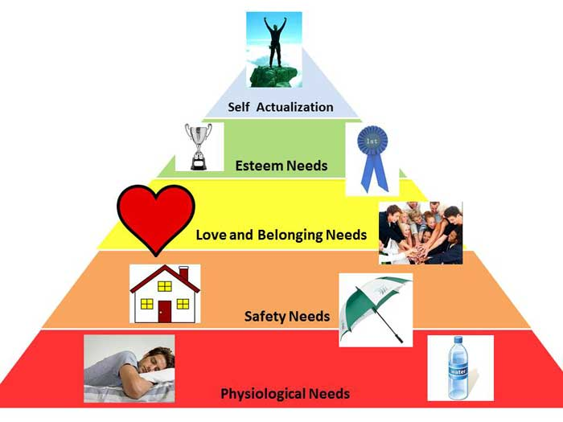
Maslow posited that human needs are arranged in a hierarchy:
'It is quite true that man lives by bread alone — when there is no bread. But what happens to man’s desires when there is plenty of bread and when his belly is chronically filled?
At once other (and “higher”) needs emerge and these, rather than physiological hungers, dominate the organism. And when these in turn are satisfied, again new (and still “higher”) needs emerge and so on. This is what we mean by saying that the basic human needs are organized into a hierarchy of relative prepotency' (Maslow, 1943, p. 375).

The expanded hierarchy of needs:
It is important to note that Maslow's (1943, 1954) five stage model has been expanded to include cognitive and aesthetic needs (Maslow, 1970a) and later transcendence needs (Maslow, 1970b).
Changes to the original five-stage model are indented and include a seven-stage model and an eight-stage model, both developed during the 1960's and 1970s.
1. Biological and Physiological needs - air, food, drink, shelter, warmth, sex, sleep, etc.
2. Safety needs - protection from elements, security, order, law, stability, etc.
3. Love and belongingness needs - friendship, intimacy, affection and love, - from work group, family, friends, romantic relationships.
4. Esteem needs - self-esteem, achievement, mastery, independence, status, dominance, prestige, managerial responsibility, etc.
5. Cognitive needs - knowledge, meaning, etc.
6. Aesthetic needs - appreciation and search for beauty, balance, form, etc.
7. Self-Actualization needs - realizing personal potential, self-fulfillment, seeking personal growth and peak experiences.
8. Transcendence needs - helping others to achieve self actualization.

Maslow (1968): Some of the characteristics of self-actualized people
Although we are all, theoretically, capable of self-actualizing, most of us will not do so, or only to a limited degree. Maslow (1970) estimated that only two percent of people will reach the state of self-actualization. He was particularly interested in the characteristics of people whom he considered to have achieved their potential as persons.
By studying 18 people he considered to be self-actualized (including Abraham Lincoln and Albert Einstein) Maslow (1970) identified 15 characteristics of a self-actualized person.
Characteristics of self-actualizers:
1. They perceive reality efficiently and can tolerate uncertainty;
2. Accept themselves and others for what they are;
3. Spontaneous in thought and action;
4. Problem-centered (not self-centered);
5. Unusual sense of humor;
6. Able to look at life objectively;
7. Highly creative;
8. Resistant to enculturation, but not purposely unconventional;
9. Concerned for the welfare of humanity;
10. Capable of deep appreciation of basic life-experience;
11. Establish deep satisfying interpersonal relationships with a few people;
12. Peak experiences;
13. Need for privacy;
14. Democratic attitudes;
15. Strong moral/ethical standards.
Behavior leading to self-actualization:
(a) Experiencing life like a child, with full absorption and concentration;
(b) Trying new things instead of sticking to safe paths;
(c) Listening to your own feelings in evaluating experiences instead of the voice of tradition, authority or the majority;
(d) Avoiding pretense ('game playing') and being honest;
(e) Being prepared to be unpopular if your views do not coincide with those of the majority;
(f) Taking responsibility and working hard;
(g) Trying to identify your defenses and having the courage to give them up.
The characteristics of self-actualizers and the behaviors leading to self-actualization are shown in the list above. Although people achieve self-actualization in their own unique way, they tend to share certain characteristics. However, self-actualization is a matter of degree, 'There are no perfect human beings' (Maslow,1970a, p. 176).
It is not necessary to display all 15 characteristics to become self-actualized, and not only self-actualized people will display them. Maslow did not equate self-actualization with perfection. Self-actualization merely involves achieving ones potential. Thus, someone can be silly, wasteful, vain and impolite, and still self-actualize. Less than two percent of the population achieve self-actualization.

APA Style References
Hoffman, E. (1988). The right to be human: A biography of Abraham Maslow. Jeremy P. Tarcher, Inc.
Kenrick, D. T., Neuberg, S. L., Griskevicius, V., Becker, D. V., & Schaller, M. (2010). Goal-Driven Cognition and Functional Behavior The Fundamental-Motives Framework. Current Directions in Psychological Science, 19(1), 63-67.
Maslow, A. H. (1943). A Theory of Human Motivation. Psychological Review, 50(4), 370-96.
Maslow, A. H. (1954). Motivation and personality. New York: Harper and Row.
Maslow, A. H. (1962). Towards a psychology of being. Princeton: D. Van Nostrand Company.
Maslow, A. H. (1968). Toward a Psychology of Being. New York: D. Van Nostrand Company.
Maslow, A. H. (1970a). Motivation and personality. New York: Harper & Row.
Maslow, A. H. (1970b). Religions, values, and peak experiences. New York: Penguin. (Original work published 1964)
Tay, L., & Diener, E. (2011). Needs and subjective well-being around the world. Journal of Personality and Social Psychology, 101(2), 354.

How to cite this article:
McLeod, S. A. (2014). Maslow's Hierarchy of Needs. Retrieved from www.simplypsychology.org/maslow.html

