Structured Discussion:
“Guess Who’s Coming to Dinner?”

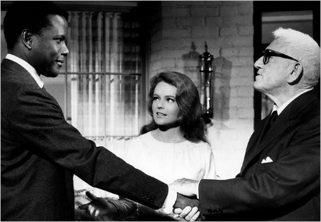
A note on Critical Race Theory:
“CRT recognizes that racism is engrained in the fabric and system of the American society. The individual racist need not exist to note that institutional racism is pervasive in the dominant culture. This is the analytical lens that CRT uses in examining existing power structures. CRT identifies that these power structures are based on white privilege, which perpetuates the marginalization of people of color. CRT also rejects the traditions of liberalism and meritocracy” (UCLA School of Public Affairs).

We have been looking at how the media portrays racial/ethnic identity using the lens of Critical race theory (CRT). We use this lens to study the connections between different groups, recognizing that race intersects with gender, class, and other systems of power. CRT aims to advance ideas of social justice by attempting to even out inequalities.

Objective: In groups, you will study the significance of mass media and popular culture in the distribution of power and the perception of different ethnic groups within the iconic film, “Guess Who’s Coming to Dinner?”

Directions: Discuss the film through the lens of CRT by posing the following four questions. Each person in your group will take one of the four roles listed below.

- Positivity Measurer Ask yourself if this film is good for people of color. Is the portrayal positive? Explain.

- Message Mapper Discuss how people of color are portrayed in the film. What kinds of messages are being sent about people of color?

- Conclusion Catcher What conclusions seem to be made about the ethnic group(s) portrayed?

- Intersection Spotter What intersectionalities (race + gender, class, ethnicity, sexuality, etc.) can you find in the film and what do they mean?

Things to consider in your discussion.

- The portrayals of Dr. John Prentice, Mr. Prentice, Tillie, and Mrs. Prentice
- The portrayals of Mr. Drayton, Mrs. Drayton, Joey, Monsignor Ryan, and Hillary St. George.

Activity Two: Write a group canvas post (approx. 500 words) analyzing the portrayal of race in the film. You can choose to focus on one of the following:

- Critics have noted that, although “Guess” is nominally about race, it is ultimately a film about the crisis in the white male establishment, whose tolerance is being challenged. Do you agree with this critique? Why or why not?
- Discuss the portrayal of Tillie, the Drayton’s maid, in the film, in respect to class, race, and gender. Do you feel her portrayal is positive according to the criteria outlined by CRT (Critical Race Theory)? Why or why not?
- Compare and contrast the portrayal of the two fathers in the film—Mr. Drayton and Mr. Prentice. Is Mr. Prentice portrayed as a “lesser father” whose opinion somehow matters less than Mr. Drayton’s?

