English 7 AP Literature
Body Biography: Candide Characters

In small groups, students will construct a Body Biography—a visual and written portrait illustrating several significant features of a character’s life in a novel, emphasizing both exterior and interior qualities.

Students have many possibilities in constructing the Body Biography—be creative and unique, but make certain your choices of information are based on the text. You will orally explain (defend) the elements you include in the body biography. Your work should help you and your classmates better understand the character and the play as a whole. Your choices should be creative, analytical, and accurate.

After completing the portrait, you will participate in a “showing” or “gallery walk” of your work in which you and your group members must accomplish the following objectives:
- Review with the class the most significant events involving the character.
- Communicate to your classmates the full essence of the character by emphasizing the character traits that make him/her who he/she is.
- Help your classmates get inside the head and heart of the character.
- Promote a discussion of the character, finding the kind of information that promotes analysis and thus a critical understanding.

BODY BIOGRAPHY REQUIREMENTS

For a grade of “C” you body biography MUST contain:
- The most significant events involving the character (5-10)
- Visual symbols—think outside the obvious! (min. of 3)
- Five most significant quotations relating to the character (does not have to be said by the character) with accurate citation in parenthesis (pg. #).
- Original text (analysis of character—commentary/analysis/explanation).
For a grade higher than a C, include other dimensions of character, more than five quotations, extensive analysis and artistic visuals.

Include

Placement Carefully choose the placement of text and artwork. For example, the location of the character’s heart might be used to illustrate important relationships.

Spine Actors often discuss a character’s “spine.” This is his/her objective within a play. What is the goal for the character? What drives his/her thoughts and actions? This is his/her “spine”; how can you best illustrate it?

Virtues What are the character’s most admirable qualities? His/her worst qualities? How can you
and Vices help us visualize them?

Color Colors are often symbolic. What color(s) do you most associate with the character? Why? Work these colors into the body biography.

Symbols What objects can you associate with the character that illustrates his/her essence? What objects in the play serve as symbols associated with the character?

Mirror, Mirror Consider both how the character appears to others on the surface and what you know about the character’s inner self. Do these images clash or correspond? What does the clashing or corresponding tell you about the character?

Changes How does the character change during the course of the play (does the character change?) Trace these changes within your text and/or artwork.

Body Biography

For this lesson, you will create a visual portrait of a character. Use this page to take notes before you create your body biography. Be sure to follow guidelines.

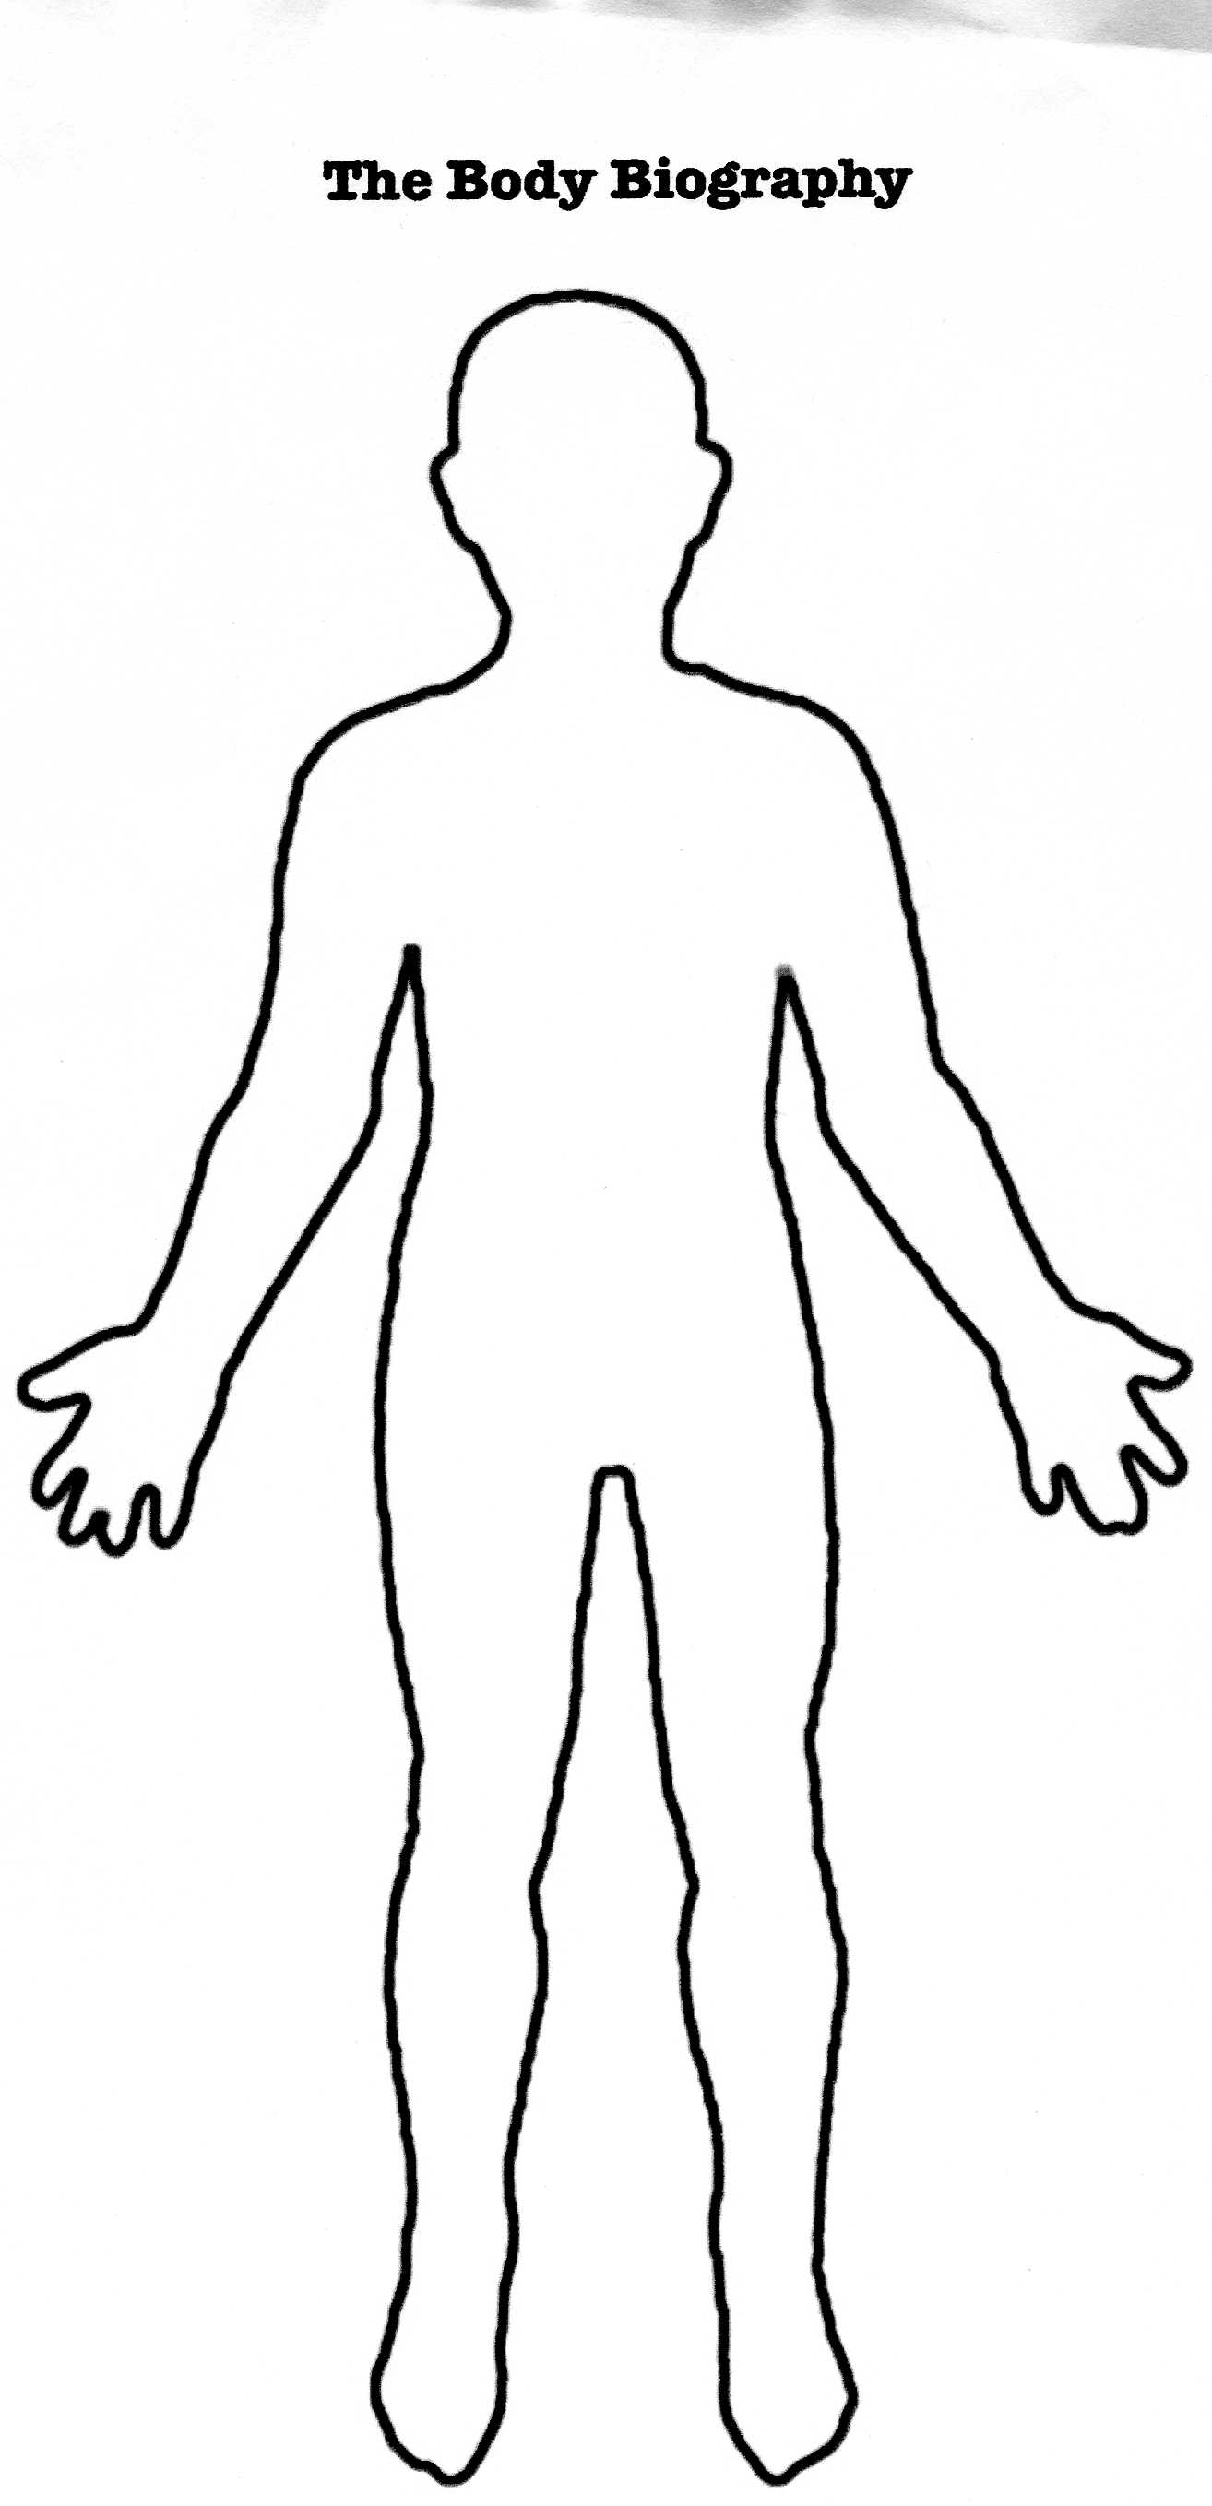
Body Biography Project

Name:______________ ________________ Character: ____________________________

Grading Rubric:

 | Score | Comments:
Body Bio
Quotes: At least three important quotes and properly cited (pg. #) given about the character and explained 5pts.
Traits/Characteristics: Important qualities about the character –at least three are given and explained. 5pts.
Symbolic Items: Important objects or symbols from the text are linked to the character. At least two are discussed.
5 pts.
Visual Appeal: Creativity, design, etc.
5pts.
External Forces: Other characters or elements that act on the character from the outside are represented
5 pts.
Presentation: Obvious knowledge about character and accurate analysis
5 pts.
Total: (out of 60)
SCALE
58-60 (A+) = 9pts.
54-57 (A) = 8pts.
51-53 (B) = 7pts.
48-50 (B) = 6pts.
45-47 (C) = 5 pts.
42-44 (C) = 5pts.
39-41 (D) = 4pts.
36-38 (D) = 3pts.
<36 (F) = 2pts.

