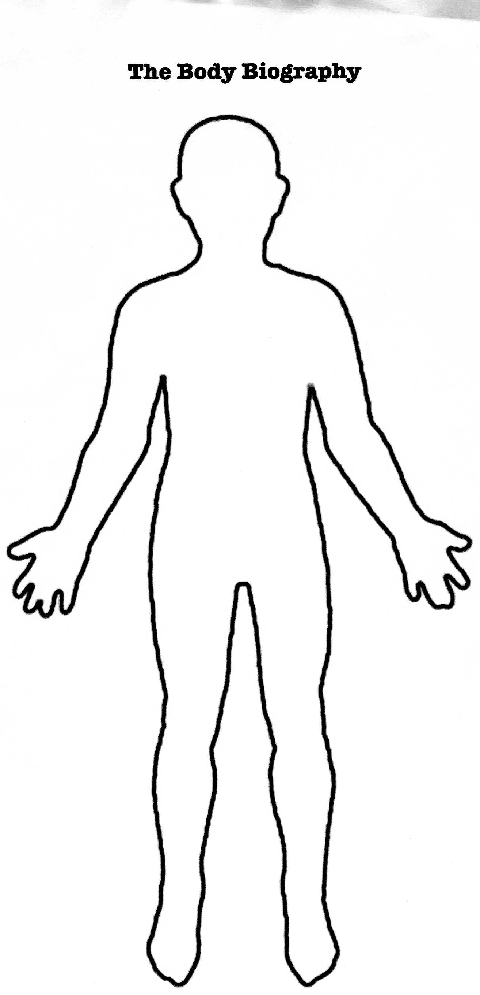
Borges and I—Body Bio

Name:______________ ________________ Character: ____________________________

Grading Rubric:

 | Score | Comments:
Poem is insightful, shows knowledge and understanding of the character, incorporates target vocabulary, and shows understanding of writer’s effect (ie looks and sounds like a poem) A01, A02, A03, A0$
30 pts.

Body Bio
Quotes: At least two important quotes and page #s given about the character and explained (A03) 5pts.
Traits/Characteristics: Important qualities about the character –at least three are given and explained. (A02) 5pts.
Symbolic Items: Important objects or symbols from the text are linked to the character. At least two are discussed. (A02) 5 pts.
Visual Appeal: Creativity, design, etc. (A04) 5pts.
External Forces: Other characters or elements that act on the character from the outside are represented (A02)
5 pts.
Presentation: Obvious knowledge about character and accurate analysis (A01) 5 pts.
Total: (out of 60)
SCALE
58-60 (A*)
54-57 (A)
51-53 (B)
48-50 (B)
45-47 (C)
42-44 (C)
39-41 (D)
36-38 (D)
<36 (F)

Name:___________________ Body Biography

Goal: Understand different aspects of yourself and the different factors (people, places, things, culture, etc.) that contribute to your identity.

Directions: Create a body bio on the back of this or another sheet of paper that represents your two “selves”—the “true” you and the “other” you that is influenced by the person society wants you to be.

For this lesson, you will create a visual portrait of your inner “selves.” Use this page to take notes before you create your body biography. Use the following guidelines.

Heart
Special relationships—Who/What is closest to you. Place this in your heart.

Spine
Important goal—What is it you are trying to accomplish? What drives your thoughts?

Strengths/Weaknesses
What is something that you admire about yourself? What is a personal quality that needs to be improved? How can you improve this weakness. Place this in the part of the body you feel represents the strength and weakness.

Changes
What changes have you undergone? Place these changes in the part of the body you feel represents these changes.

Mirror, Mirror
How do you see yourself? How do others see you? Place this idea in the part of your body (or outside your body!) you feel represents how you see yourself vs. how others perceive you.

Outside Influences
What outside forces influence you? Place these on the outside of your body.

Symbols
What objects could be used to symbolize or represent your “selves?” Place these in the parts of your body you feel most appropriate.

Words/Phrases
Place any words or phrases that represent your “selves” within or around your body.

Use pictures, symbols, and words to create a body bio for your character. You will be graded on completion and creativity. Use your imagination and BRAIN POWER to bring the character to life.

