Name:____________________________________

Preparing an Annotated Bibliography

Classes that require you to do research often require an annotated bibliography. An annotated bibliography is a useful way to start a research project because it asks you to collect and summarize sources that you might use later in your research paper/project. Collecting and summarizing sources early in the research process helps you narrow your research topic. The bibliography can also help you evaluate the possible usefulness of source material.

This handout is designed to show you how to create an annotated bibliography. Specifically, it will guide you through the process of creating an annotated bibliography by

- describing in general terms the meaning of the words “annotated bibliography,”

- explaining in general terms how to write an annotated bibliography, and

- offering an example of what an annotated bibliography could look like.

What is an Annotated

Bibliography?

If you have been assigned to write an annotated bibliography, you might be confused about what the words "annotated" and "bibliography" mean. The word “annotated” is the past tense form of the verb “to annotate” which means to summarize. An annotation is simply a summary of a book, article, or some other written source. A bibliography is a list of sources on a particular topic. Put together, an annotated bibliography is a list of sources on a topic that offers a summary for each source.

What does an Annotated

Bibliography look like?

An annotated bibliography has two parts. The first part is the bibliography line which should be written according to MLA format. (The sample attached uses MLA format. Refer to Purdue Owl for assistance in citing various types of sourcs.) The second part is the summary paragraph. Both parts taken together are called an “entry.” Entries are typically organized in alphabetical order according to the bibliography information, such as the last name of an author or the title of a book.

The number of entries in a bibliography depends upon the assignment. The attached example is made up of two entries which offer a good example of the bibliography line and summary that are the key parts of any good annotated bibliography.

How is an Annotated
Bibliography summary written?

Timothy Crusius and Carolyn Channell in The Aims of Argument suggest that your summary should include the following elements:

- a sentence or two that describes the author's credentials, purpose, and audience,

- a brief “capsule” summary of its content, and
- a sentence at the end of the summary that explains “why this source seems valuable and how you might use it” (255).

Both of the summaries in the attached example include the three kinds of details listed above. When looking at the example summaries, look at the way the writer has blended these three components together rather than listing them one after another.

Created by Teresa B. Henning, Updated 2011

Work Cited:
Crusius, Timothy and Carolyn E. Channell. The Aims of Argument. 3rd ed. Mountain View, CA: Mayfield, 2000. Print.

This sentence describes what is useful in the article.

that may not be well protected. For instance, as Alderman and Kennedy point out, most bank, insurance, medical and pharmaceutical records are stored on computers others may be able to access. A good example the authors provide of such ease of access is an incident in which a reporter was able to get Dan Quayle's credit report with a phone call, fifty dollars, and a home computer.
Furger, Roberta. “Washington Tackles Internet Law.” PC World. PC World, 1 Sept. 2007. Web. 9 Dec. 2007. Internet expert and best-selling author, Roberta Furger informs the general public of the many Internet related bills that congress is considering. Furger claims that a more comprehensive law to govern the collecting of sharing on the Internet is needed that meets the needs of both privacy advocates and internet service providers. Furger supports this claim by detailing the ways that proposed bills fail to adequately meet the needs of either of these two groups. The article offers a useful listing of bills that are currently before congress.

These lines list the sources’ bibliography info. in MLA format.

A Selected Annotated Bibliography on Privacy and Technology Alderman, Ellen, and Caroline Kennedy. Right to Privacy. New York: Vintage, 2004. Print.
The authors of this informative national bestseller, who have experienced privacy violations of their own, make the claim that since there is no comprehensive agenda to solve the problem of informational privacy, American citizens will have to be concerned about protecting their personal information. One reason the authors give to support their claim is that most of citizens’ personal information is already being stored on computers

Student’s Name Teacher’s Name Course
Date

This part of the sentence describes the authors, their purpose
&

A summary of the book is offered here.

This sentence describes the useful part of the source.
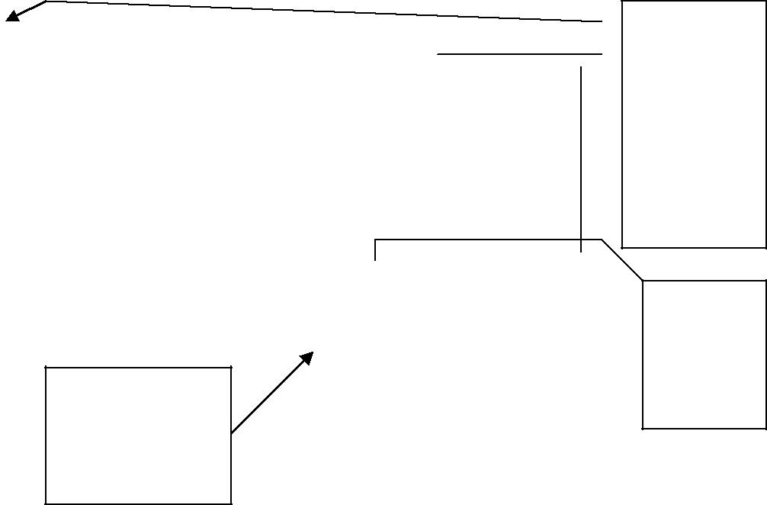

This part of the sentence describes the author, purpose, & audience.

A summary is offered here.

